

*“Reclaiming*

*the*



*Reunion Date*

*July 26th*

*-*

*2019*

*28*

*th,*



POWER



*Of*

*the*



VOTE

”

# REUNION WELCOME



November 1, 2018

Dear Member,

The Paschal-Bentley Reunion will be from July 26-July 28, 2019. The planning committee has been busy making arrangements for things that we know will be fun and exciting for the entire family.

We have chosen the Doubletree by Hilton Birmingham at 808 20th Street located in the heart of downtown Birmingham. The daily rate is $140.00 plus tax per night with a two-night minimum stay. You must make your reservations by (date, terms of payment, restrictions will be supplied by the hotel). Please note that there are (20) rooms blocked off for our group. If you register through the website, you can prepay for your room.

Registration is available on the website or my mail. We look forward to seeing everyone in 2019!

Sincerely,

Donald Davis

2019 Reunion Committee Chair

# REGISTRATION



Name

Address: ____________________________ City__________ ST _____ Zip______

Phone : E-mail: ______________

**REGISTRATION FEES**

ADULTS – $125.00 YOUTH (Ages 12 to 18) - $70.00

CHILDREN (Ages 5 to 11) $40.00 CHILDREN UNDER 5 – Free

**\*\*All Registrations and Payments are Due by July 5, 2019\*\***

To send your payment by mail the address is: PO Box 14162, Augusta, Ga 30919

**Reunion fees cover the cost of the following:**

* Friday – Arrival Meet & Greet
* Saturday - Lunch, City Tour, All Admissions, and Dinner/Banquet
* Sunday - Breakfast

|  |  |
| --- | --- |
| NO. OF PEOPLE ATTENDING | ADULTS CHILDREN |
| TOTAL COST: |  |

**Specify family member T-shirt sizes and genda by :**

SMALL____ MEDIUM ____ LARGE____ XL____ XXL____ XXXL ____

Youth size______ Male_______ Female_______

Special Requirements: (i.e., dietary needs, disability needs, etc.)

_______________________________________________________________________

Make check payable to: Donald Davis: Total $______________________________

Notes

## REUNION AGENDA

### Friday July 26, 2019

11:15 AM (EDT) Departure on chartered bus from Augusta to Birmingham If needed, stops in Thomson and the Atlanta Area.

*\*(1 Hour Time Zone Change from Eastern to Central)*

4:00 PM Arrival in Birmingham and check in to hotel

6:00-08:00PM Meet & Greet – Doubletree by Hilton

### Saturday July 27, 2019

|  |  |
| --- | --- |
| 8:30AM | Depart hotel for site seeing and lunch. 1st - Ingram Park. |
| 9:50 AM | 16th Street Baptist Church for our 10:00 tour. |
| 11:30 AM | St. Paul United Methodist Church  Lunch & Family Meeting Site |
| 01:00 PM | Birmingham Civil Rights Institute. |
| 03:00-4:00PM | Bus tour of other sites that were important to the Civil Rights Era. |
|  | (Tentative) |
| 07:00-09:00PM | Family Reunion banquet Doubletree Hotel. |

### Sunday July 28, 2019

6:00-10:30AM For those who are traveling by our chartered bus there will be breakfast available at the hotel. A prepaid coupon for breakfast is required for each person.

11:00AM (CDT) Depart Birmingham for travel back to Augusta, GA.

*\*(1 Hour Time Zone Change from Central to Eastern)*

06:00PM (EDT) Estimated arrival to Augusta, GA

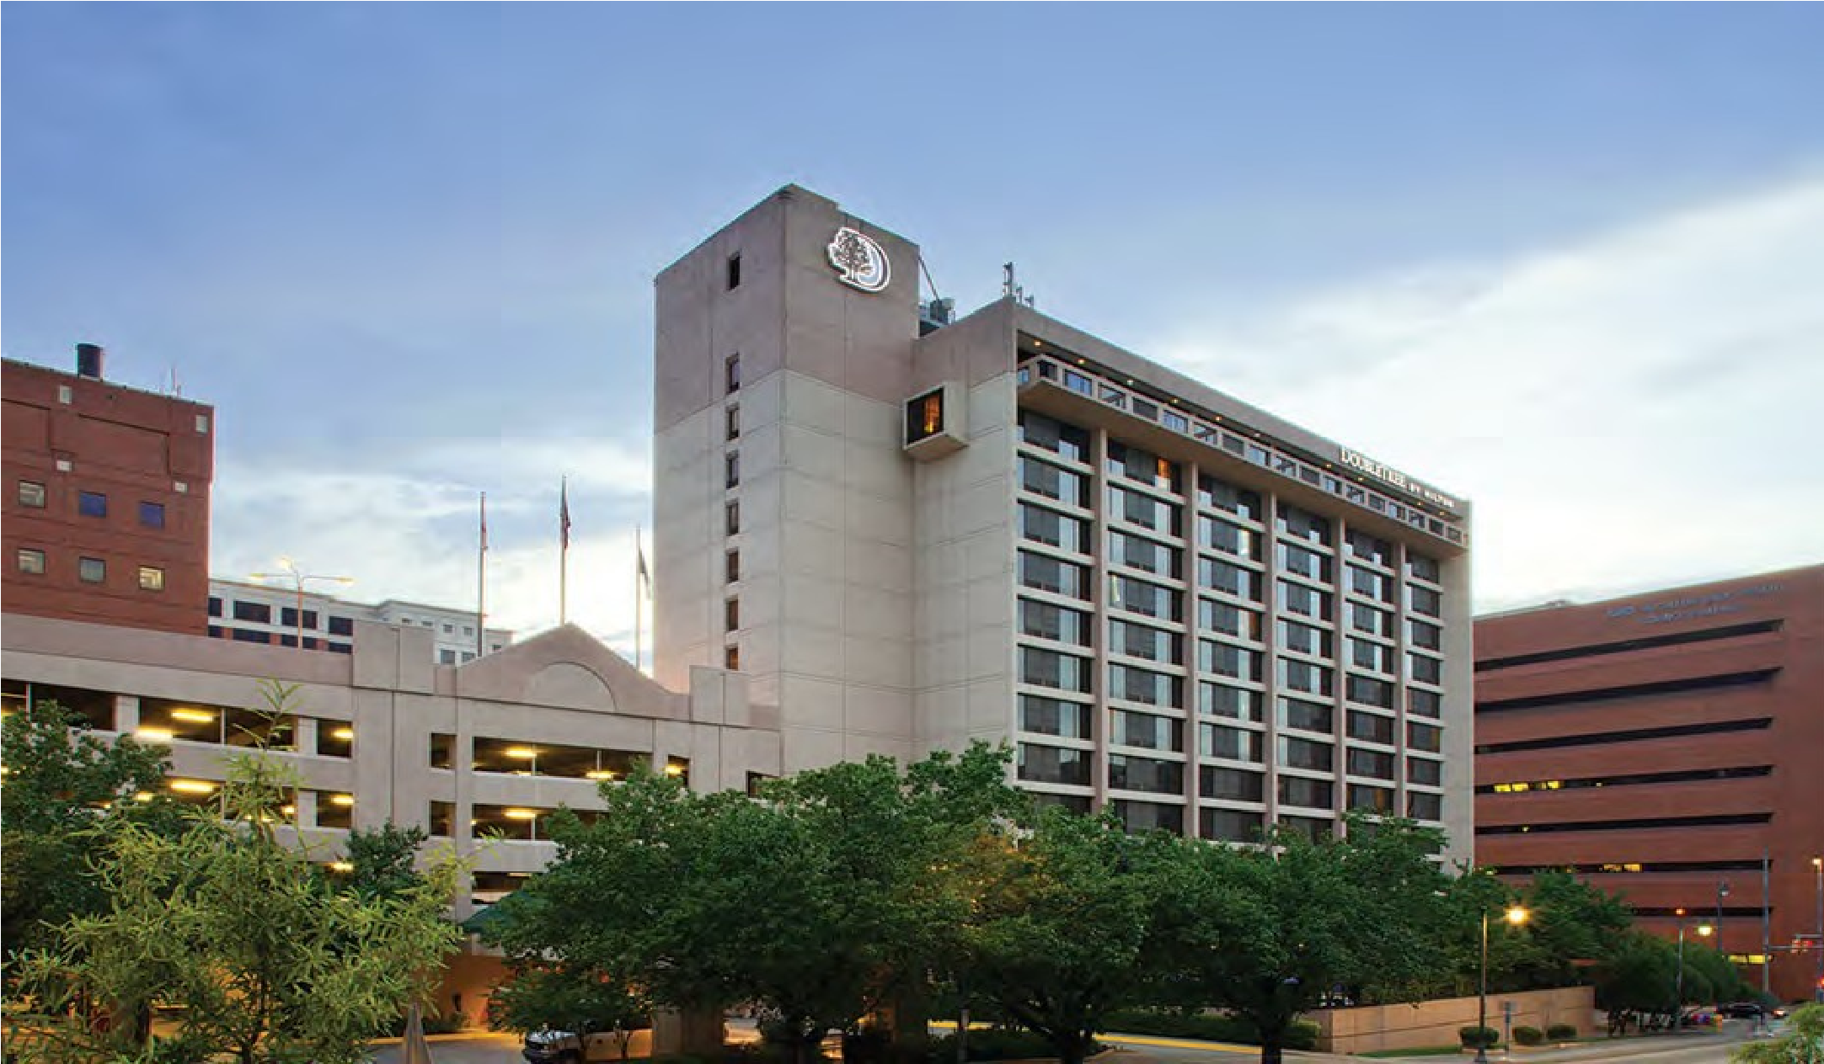

HOTEL ACCOMODATIONS

A block of 20 rooms are being held downtown Birmingham at the Doubletree Hotel. The rate is $140 per night (inclusive of all taxes for two people). Additional cost per person per room will be $15.00. Guest rooms will be either one king or two doubles.

The hotel is requiring a 2 night minimum stay. For more information, please visit the reunion website or the hotel’s website to book your room.

Parking

-

$5 per night

Doubletree by Hilton Birmingham

808 20

th

Street | Birmingham, AL 35205

T: 205.933.9000 | F:

205.533.8178

www.birmingham.doubletree.com

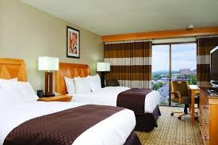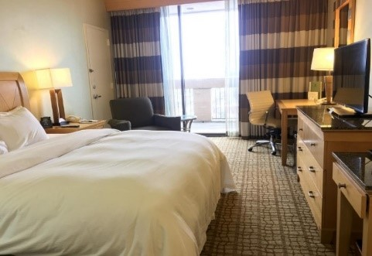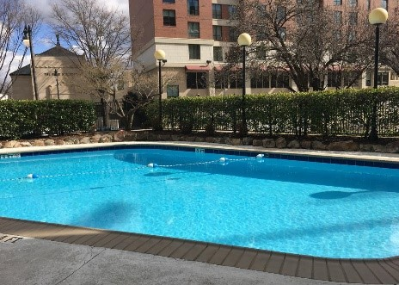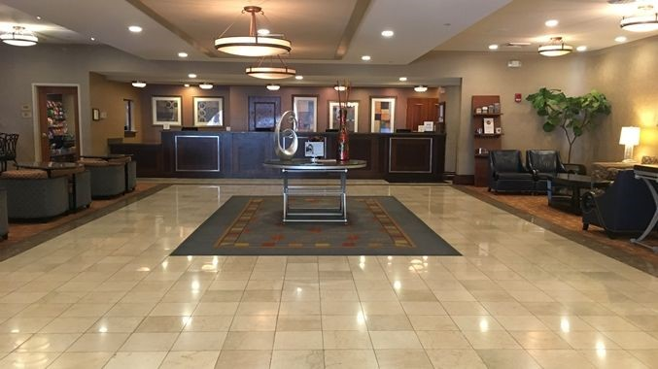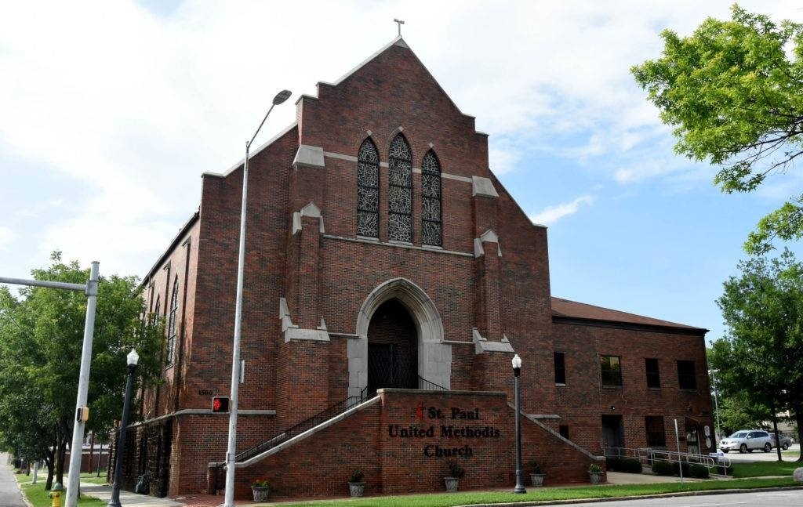

ITINERARY

Weekend activities will include a welcoming reception at the hotel where family will get to renew relationships and make new ones. There will be games and other activities. The hotel pool will be open for those who want to go for a swim or just sit by the pool.

We will start the day Saturday with an optional breakfast in the hotel restaurant followed by visits to historic Civil Rights sites in Birmingham. We will begin at the 16th Street Baptist church where we will have a presentation on the horrific events that resulted in the deaths of four girls as they prepared for Sunday school in 1963.

After the tour and presentation at the 16th Street Baptist church, we will spend the remainder of the day exploring other historic sites that include Kelly Ingram Park. Be sure to bring your cellphone and earbuds for this self-guided tour. There are sites throughout the park such as the one below where you can hear an account of what that statue represents through your cellphone by entering a code for a recorded narration.

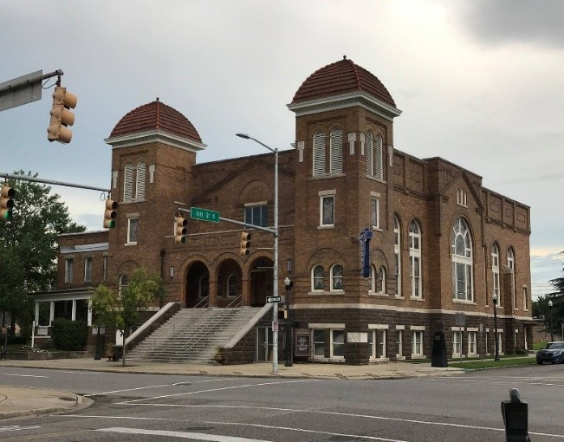

TRANSPORTATION

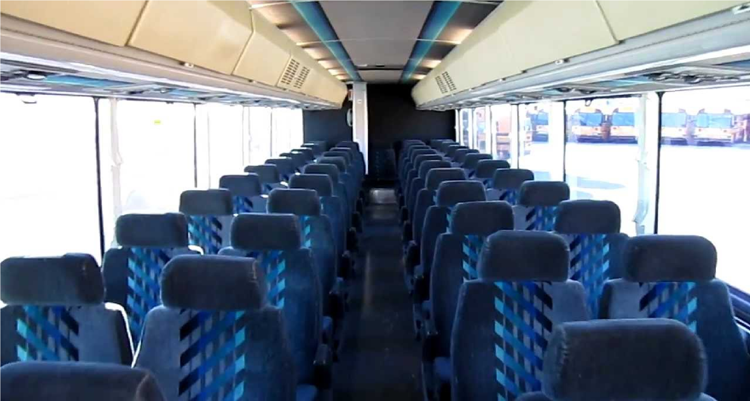

Round trip bus travel from Augusta, Georgia to Birmingham, Alabama will accommodate 52 passengers. This a first come first serve basis. To pay for your transportation, please see below the methods of payment:



### Cost - $65.00

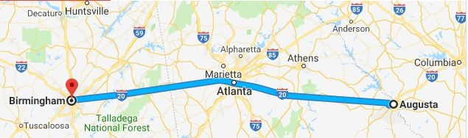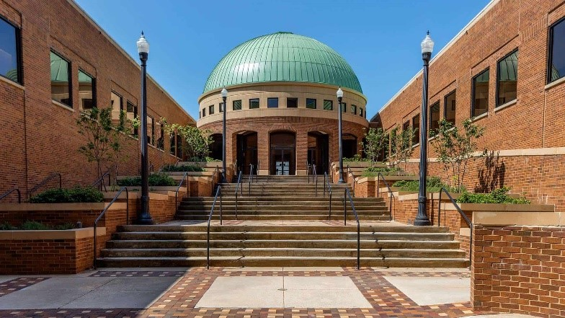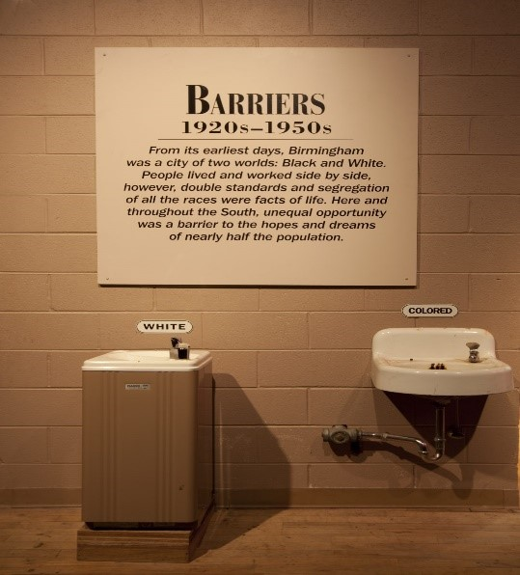

ITINERARY

Most of the time will be spent at the Birmingham Civil Rights Institute. Which along with several sites in the area have been designated as a part of the Civil Rights National Monument in Birmingham and is now a part of the National Park Service. Here you will be able to see artifacts from the “Jim Crow” era.

We will have lunch on Saturday at the St. Paul United Methodist Church. The site where the Children were trained and assembled for the protest marches downtown where many were jailed and assaulted with fire hoses and dogs.

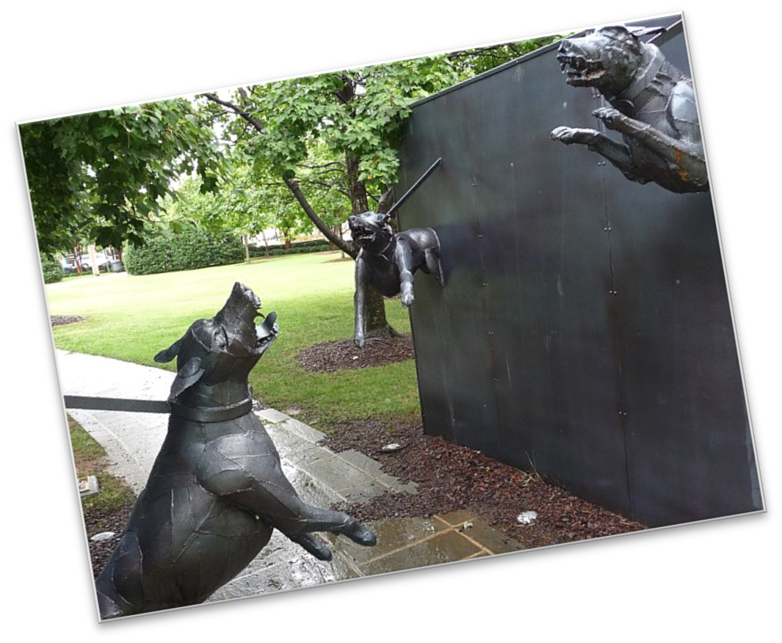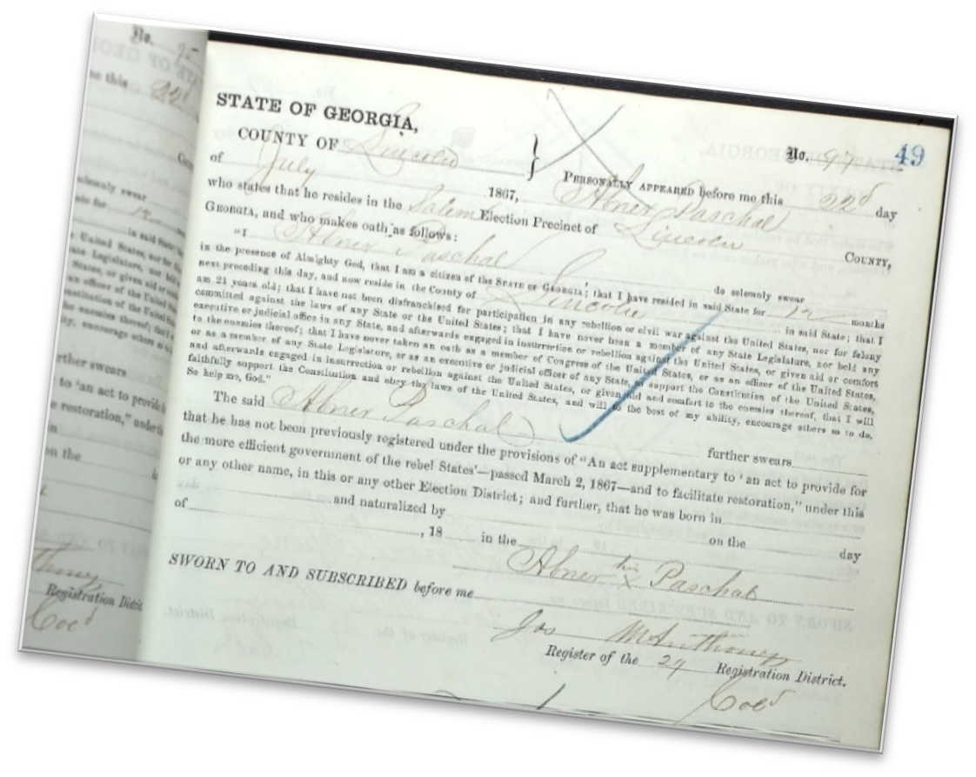

If time permits, we will take a bus tour of neighborhoods in the city that were subjected to bombings during the Civil Rights struggle. There are still some homes today where the repairs from being bombed are still evident.